­

**If you are new to the pantry, please be prepared to provide the following:**

1. A **form of ID** for **each member** in your household: This includes a driver’s license; state, military, or tribal ID; passport; birth certificate or baptismal records; WI Immunization records, report cards, library cards, or first-class mail addressed to the particular household member postmarked within 30 days.

2. **Proof of Address**: Provide First-class mail postmarked within 30 days (a second piece of mail if using mail as your ID); rent/mortgage receipt; rent or lease agreement; a property tax bill.

3. **Income**: You must be able to self-declare that your household meets the income guidelines to receive food. Current income guidelines for eligibility to participate in the food distribution program are posted.

**If this is a subsequent visit, please be prepared to provide the following at the time of registration each month:**

1. **A form of ID** for the person picking up the food

*2. Proof of Residency (Only if this has changed since your last visit)*

**2019 DISTRIBUTION DATES**

January 29, 30

February 26, 27

March 26, 27

April 23, 24

May 28, 29

June 25, 26

July 30, 31

August 27, 28

September 24, 25

October 29, 30

November 26, 27

December 17, 18

**LOCATION:**

Gebhardt School

411 Gebhardt Rd., Black River Falls, WI 54615

**TIME:**

Tuesday: 4:30pm-6:00pm

Wednesday: 9:30am-10:30am

**FOR MORE INFORMATION**

Phone: 715-896-3601

For emergency help 715-670-8489

**EMAIL:**

[tefap@wdeoc.org](mailto:FoodAssistance@WesternDairyland.org)

In accordance with Federal law and U.S. Department of Agriculture policy, this institution is prohibited from discriminating on the basis of race, color, national origin, sex, age or disability. To file a complaint of discrimination write USDA, Director, Office of Civil Rights, 1400 Independence Ave, SW, Washington, D.C 20250-9410 or call (800) 795-327 or (202) 720-6382 (TTY). USDA is an equal opportunity provider and employer.

**Remember to bring containers to put the food items in!**

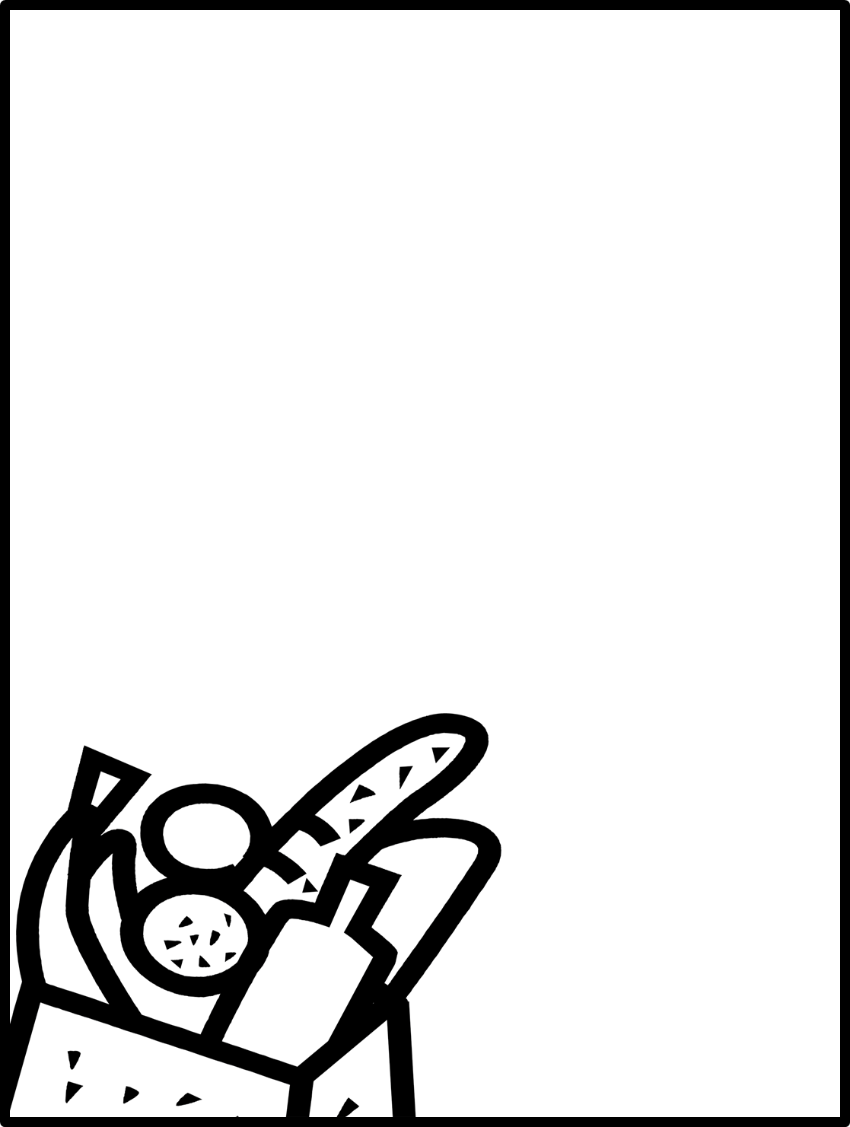

**JACKSON COUNTY**

**FOOD PANTRY**