CAN FOLIAR FERTILIZATION IMPROVE CROP YIELD?

Carrie A.M. Laboski 1
Can foliar fertilization improve crop yield where no signs of nutrient deficiency can
be seen? This is an often asked question which unfortunately does not have a black and
white answer. The objective of this paper is to briefly highlight what is known about leaf
functions and provide an overview of the performance of foliar fertilizers.
Supplying nutrients to plants is a primary function of roots and not leaves. Though
not a primary function, nutrients may enter a plant through leaves. Nutrient uptake by
leaves is much less than roots, but like roots, many factors impact the uptake of nutrients
from leaves. Marschner (1994) provides a list of concerns related to foliar application of
nutrients: (1) Low nutrient penetration rates, particularly in plants with thick cuticles;
(2)Runoff from hydrophobic leaf surfaces; (3) Washing off by rain; (4) Rapid drying of
spray solutions; (5) Limited rates of translocation of some nutrients; (6) Limited amounts
of macronutrients that can be supplied by one foliar application; and leaf damage.
Marschner (1994) also provides some guidance on where foliar nutrient applications may
be beneficial. They include: (1) Soils where nutrient availability is low. This is
particularly true for micronutrients on soils with a high pH and high organic matter
content. (2) Conditions where dry topsoil limit nutrient availability. (3) At the onset of
reproduction when root activity decreases and nutrient uptake is reduced.
Of most interest recently is foliar application of nutrients at the reproductive growth
stages. In 1976, Garcia and Hanway sparked this question when they reported significant
soybean yield increases that ranged from 1.2 to 8.0 bu/acre when N-P-K-S fertilizer was
applied two times at R4 and R5, R5 and R6, or R6 and R6.5. Subsequent research results
have been disappointing compared to Garcia and Hanway’s work. Gray and Akin (1984)
report on a study conducted in 28 states and found that on average soybean yield
decreased 5.2% with the foliar application of nutrients. Parker and Boswell (1980)
reported a 10.9 and 17.6% soybean yield decrease with application of foliar fertilizers. In
corn, foliar applications of N-P-K-S after silking were reported to temporarily reduce
photosynthesis and subsequently yield was reduced by 6.4% (Harder et al., 1982).
In more recent work in Minnesota, Rehm (2003) reported that one to three
applications of N-P-K-S applied after silking resulted in corn yield increases and
decreases on the order of -5.8 to +4.7 bu/acre. In Iowa, Sawyer and Barker (1999) found
that foliar application of urea and mono-potassium phosphate at V6-V8, V12-V14, or
50% VT had minimal impact on corn grain yield.
With regard to soybeans, Rehm et al. (1997) showed no yield benefit when
soybeans were sprayed with repeated applications of N-P-K-S at pod filling. DiFonzo and
Laboski (unpublished data, 2004) found that application of N-P-K + micros at R3 and R5
resulted in yield decreases and increases that ranged from -3.3 to +0.8 bu/acre. At the
current price of soybeans ($5.50/bu) and the fertilizer used, a minimum yield increase of
3.1 bu/acre would have been required for this practice to be economical. Additionally,
locations where the greatest yield decreases from foliar fertilization occurred coincided
with the most evenly distributed rainfall throughout the growing season.
While it is possible for foliar fertilization to increase yields, it appears that the
conditions under which a yield increase is assured are unknown. The variability in
positive and negative yield responses and the lack of economical yield responses are such
that widespread practice of foliar fertilization to boost yields is not recommended.
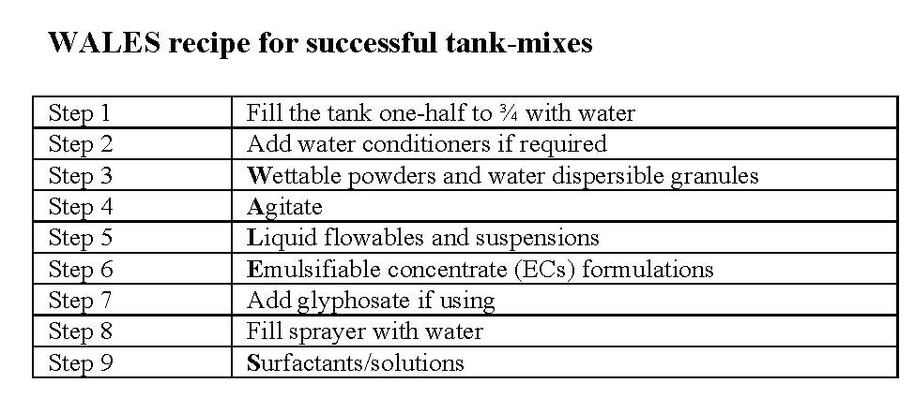

Is Metabolic Herbicide Resistance the Straw That Will Break Weed Management’s Back?

Jed Colquhoun, UW-Madison, Extension Weed Scientist
In a long-term tillage research project in Kansas, a Palmer amaranth population was identified that was resistant to six herbicide sites of action in individual plants. While that’s challenging enough, here’s the scariest part: in some cases the plants had evolved resistance to herbicides that had never been sprayed in the field (Shyam et al. 2021).
Similarly, in Illinois a waterhemp population was recently identified that’s resistant to dicamba, yet the field had never been treated with dicamba or 2,4-D. The population was also resistant to five other herbicide sites of action, which may have been the source of resistance to the sixth herbicide site of action that includes dicamba (see https://aces.illinois.edu/news/first-dicamba-resistant-waterhemp-reported-illinois for an informative summary of this work).
Weeds that have become resistant to herbicides they’ve never been sprayed with may sound like something out of a CSI type show. The phenomenon is not new but is becoming more common. In fact, one of the potential causes – metabolic resistance – isn’t even limited to plants. So how could this happen?
In a broad sense, herbicide resistant weeds can be divided in two groups: those with target site resistance, and those with non-target site resistance. In target site resistant weeds, the specific enzyme that the herbicide targets is either mutated so that the herbicide can’t bind to it (think of pieces of a puzzle not fitting together) or the target enzyme is overproduced to the point that the herbicide can’t effectively bind to all the sites.
Non-target site resistance can happen in a few ways: in resistant weeds the herbicide may not be absorbed or translocated (moved within the plant) as well, the herbicide may get sequestered in plant parts away from the target site, or the herbicide may get metabolized by the plant. The remainder of this article will focus on metabolic herbicide resistance because it likely has the greatest implications for production agriculture.
Herbicide metabolism involves the breakdown of the active ingredient into metabolites that are less mobile and less toxic to the plant, and then the “dumping” of the metabolites into plant parts where they are sequestered and not active. Enzymes cause the breakdown, and two of the most involved include cytochrome P450 monooxygenase (P450) and glutathione S-transferase (GST). P450s are among the most common enzymes in living organisms and have the ability to metabolize 11 of the 26 herbicide modes of action. GSTs are also common in living organisms and are responsible for some grass tolerance to herbicides and some observed cases of insecticide resistance (Rigon et al. 2020). Crop safety with many herbicides is based on metabolism by these broad enzymatic families.
Herbicide metabolism has been researched and observed over the past few decades with challenging grass weeds such as rigid ryegrass in Australian wheat production (Yu and Powles 2014). More recently, however, metabolic resistance has been reported among broadleaf weeds and close to home. For example, metabolic resistance to the herbicide S-metolachlor was reported in two waterhemp populations in Illinois (Strom et al. 2020). In this case the resistant waterhemp metabolized 90% of the S-metolachlor in less than 3.2 hours.
Metabolic resistance has sometimes been referred to as “creeping resistance” because of the way that it evolves in populations, where plants that can survive low herbicide doses by metabolizing some of the active ingredient produce seed, and subsequent generations are selected that can metabolize more and more herbicide until they are no longer useful for control. For example, waterhemp control with dicamba in the Illinois population noted above decreased from 80% to 65% over just a few years, and dicamba wasn’t even sprayed during that time.
So why is metabolic resistance so concerning compared to target site resistance that’s been addressed for years? Target site resistance is very specific to an herbicide active ingredient, the individual target site that it binds to, and a mutation that changes those puzzle pieces. In contrast, in metabolic resistance the enzymatic activity that breaks down the herbicides and other toxins is not specific. Once high metabolic activity is selected for, the plant can breakdown a broad range of herbicides across modes of action, potentially including active ingredients that have never been sprayed on that population before, and even herbicides that have yet to be discovered. For example, in the Kansas study mentioned above, the authors concluded that “these results suggest predominance of metabolic resistance possibly mediated by cytochrome P450 and GST enzyme activity that may have predisposed the KCTR Palmer amaranth population to evolve resistance to multiple herbicides” (Shyam et al. 2021). In practical terms, metabolic resistance adds tremendous unpredictability to weed management decision making and outcomes.
These metabolic enzymatic activities are also not specific to plants and herbicides, which makes for complex resistance scenarios. For example, Clements et al. (2018) reported that some of the fungicides commonly used for potato disease control can upregulate GST enzyme production in Colorado potato beetles, and that increase in enzymatic activity can negatively affect insecticide performance.
Additionally, not only is metabolic resistance more challenging to research than target site resistance, it’s also harder to observe in the field. For years growers and scouts have been told to keep an eye out for living target plants that normally would have been killed and that are among other dead weeds, and that stark contrast of living versus dead was often the smoking gun of resistance. In metabolic resistance, the selection pressure creeps along where target weeds may be injured but eventually recover enough to produce a few viable seeds, and the high metabolism selection cycle continues on until multiple herbicides are ineffective.
The increase in likely cases of metabolic resistance observations in recent years speaks to the dire need to develop practical and economical alternatives to herbicides – it’s simply not just about rotating herbicides anymore. In the short term, much effort is currently being directed to intervening in the seed production and dispersal step of the resistance selection cycle with mechanical tools like combine weed seed cleaners and collectors. Research is also underway to gain a better understanding of the complex metabolic interactions among pesticides and pests, and how that affects practical management decisions. In the longer term, alternative technologies like weed sensors and highly efficient robotic weeders need to be developed and available for adoption in reasonable and affordable ways.
Attention Jackson County farmers: I am looking for a cooperator farm to host a biological product test plot in corn. The plot will look at Envita and Utrisha along with varying nitrogen rates. The plot will take about an acre of a field. The field should not have any nitrogen applied in the fall or pre-plant in the plot area. I will need an area that is not in a headland. The field can have manure applied if the rate is light and uniform. The previous crop can be soybean, small grain, or corn. A uniform soil type is best with a low slope. If you are interested, please contact me either email at steven.okonek@wisc.edu or 715-538-5097. Thank you.
Calendar
No events planned for the spring season. Stay tuned for summer field days!

