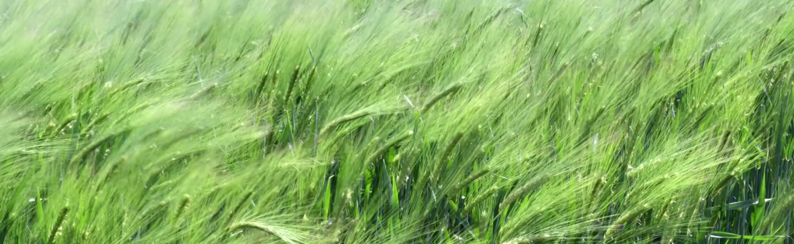
Summer Agriculture Newsletter, 2023
What started out to be a wet spring, with 20+ inches of snow in central Jackson County, in April, has now become dry. This newsletter is intended to provide helpful information to reduce the impact of the dry spring. I hope and pray that it rains soon, and I am wrong in assuming the rest of the summer will be dry. As the saying goes, hope for the best, prepare for the worst.
Corn
Yield potential has not yet been impacted by the dry weather, assuming a good stand has been established. Dry weather early in the season will help corn establish a deep root system. If uneven emergence occurs due to planting into dry soil, evaluate the stand. Late emerging plants can act as weeds to the early emerging corn plants and late emerging plants can have soft, wet grain. If corn silage, snaplage, or high moisture corn is an option, the impact of late emerging corn will not be as dramatic as it could be in a dry grain harvest scenario. If silage or high moisture grain is not an option, consider cultivating the field and burying the late emerging corn.
Weeds take moisture away from our crops and the sooner we can control the weeds, the better.
Weed control is an issue that will be impacted by the dry weather. Obviously, you want to control weeds as soon as possible. Weeds take moisture away from our crops and the sooner we can control the weeds, the better. Weeds that emerge before or at the same time as the crop have a greater impact on crop yield. Weeds that emerge after the crop have less impact and weeds that emerge in the crop row have a greater impact than weeds that emerge in the middle of rows.
Activating pre-emerge herbicides can be an issue in dry weather. Acetochlor and S-metolachlor both require 0.5 inch to one inch of rain to become effective. The herbicides need to be in the top 0.5 to one inch of soil and in the soil water solution to be absorbed by weed seeds as the seeds germinate. Pre-emerge herbicides applied to dry soil will have insignificant effect on weeds emerging from deeper soil depths. Also, if weeds emerge through the herbicide layer and the herbicide becomes activated later, there may be insignificant effect on the weeds. If possible, rotary hoeing or lite tillage with a tine weeder or tine harrow will help uproot small weeds and help move the herbicide into the soil.
Post-emerge herbicides can also face challenges in dry weather. The cuticle, or the outer layer of the plant leaf, becomes thicker to conserve water. Penetrating the cuticle is important for post-emerge herbicides to function. Be sure you are using the proper adjuvants at the proper rate for all the products you are applying. Double check tank mixes under drought conditions. You should always read and follow label directions. Reading and following label directions is doubly important under drought conditions as some labels have special sections dealing with weeds growing under drought conditions.
We need to eliminate variables and give the plants everything they need and at the same time, the odds of getting a positive response to added nutrients is low.
Soil fertility can be challenging in dry conditions. We need to eliminate variables and give the plants everything they need and at the same time, the odds of getting a positive response to added nutrients is low. Assuming low soil test phosphorus and potassium levels have been addressed and pH is adequate, nitrogen rates can be less in a dry year than in a year with normal precipitation because nitrogen is not likely to be the factor that limits yields. Infact, test plots around Wisconsin and the Mid West show corn grain yield tops out at nitrogen levels of 120 pounds per acre to 180 pounds per acre. Seldom is it required to have 200 pounds per acre of nitrogen to reach 200 plus bushel yields of corn. If you need to apply a side dress application of nitrogen, reduce the rate you normally apply. If you end up around 160 pounds per acre of nitrogen, you will have plenty to maximize yields if precipitation returns to normal levels.
Foliar diseases will be less common in a dry year. Do not apply fungicides to maintain plant health in absence of diseases. If conditions are not conducive to fungal growth, you will not get a return on applying fungicides. Think about fungal diseases as a three-legged stool or a triangle. Each leg on the stool or side of the triangle is another factor in determining if the plant will be infected with a disease. Eliminate one of the points or legs and you will not have a disease infection. You need a host. The host is the crop we planted. We can select varieties that are resistant to a disease and eliminate the host plant. The pathogen is an infectious agent or disease. Crop rotation can help control the presence of a pathogen, but in most cases, pathogens are difficult to control as spores can move on wind currents from long distances away. The environment is the biggest variable. Plant pathogens need plant leaves and plant parts to be wet for at least part of the day. Heavy dew or rainy days will provide an environment conducive to pathogen growth. So far, we have not had an environment friendly to pathogen growth. Fungicides are not effective for more than a few weeks. Fungicides applied during dry weather because we always apply fungicides at a certain growth stage may not be effective by the time or if the weather changes and we need a fungicide. Until the environment changes, do not apply fungicides to corn or soybean crops in 2023.
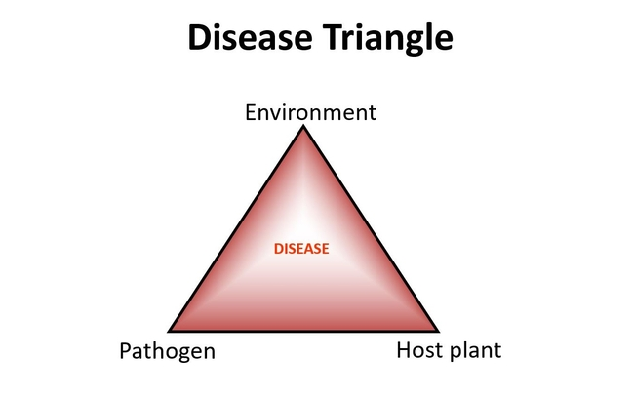
Pollination is the next step in developing a crop. If pollination is successful, allow the crop to develop and harvest as planned. To determine if pollination has been successful, carefully husk the ear upside down. Silks that have not been pollinated will remain attached to the cob. Partially pollinated ears will contribute to yield as the kernels mature. Obviously, the more kernels that pollinate, the higher the yield potential for both silage and grain production. Harvesting silage too early will reduce yield and feed quality. Barren plants will have a higher moisture content than expected so be sure to watch harvest moisture. If pollination is not successful and rain returns after pollination, barren plants will accumulate sugar in the leaves and stalks if the plants are left to grow. Carbohydrates flow from source (leaves) to sink (ears or growing tissues) in the plant. If the plant is mature and there is no grain to fill, there is no sink. The carbohydrates accumulate in the leaves and stem of the plant. The plant will eventually become clogged with carbohydrates and turn red or orange. Think of a sweet corn plant with all the ears picked off. The red stalk on sweet corn is an accumulation of carbohydrate in the plant. This accumulation of carbohydrates will impact the feed value of the silage. This is important if areas of the field have pollinated, and areas have not pollinated. Allowing the field to mature to the proper grain maturity stage will increase yield and feed value of both pollinated and unpollinated areas. Avoid chopping corn too early.
Soybean
Soybean yield potential has not been impacted by dry weather if a uniform stand has been established. Seeds planted into dry soil may remain viable for an extended period if the seeds do not imbibe water and begin to germinate only to dry out later. Roots of any plant will not grow through dry soil. If seeds are planted in dry soil and enough rain is received to germinate the seed but not enough water is received to wet the soil profile, roots will grow until they hit dry soil and stop. The plants that hit dry soil may die if more rain is not received. Soybeans flower based on day length so late emerging plants in a stand may not impact yield as negatively in soybean as late emerging plants can impact corn yields.
Weed control will be the next challenge in dry weather. While herbicides may be different from corn to soybeans, many are the same and the principles of activation and effectiveness are the same. Refer to pre and post herbicide sections in the corn discussion. Always read and follow label directions.
Foliar diseases will be less common in a dry year. Do not apply fungicides to maintain plant health. If conditions are not conducive to fungal growth, you will not get a return on applying fungicides. Think about fungal diseases as a three-legged stool or a triangle. Each leg on the stool or side of the triangle is another factor in determining if the plant will be infected with a disease. Eliminate one of the points or legs and you will not have a disease infection. You need a host. The host is the crop we planted. We can select varieties that are resistant to a disease and eliminate the host plant. The pathogen is an infectious agent or disease. Crop rotation can help control the presence of a pathogen, but in most cases, pathogens are difficult to control as spores can move on wind currents from long distances away. The environment is the biggest variable. Plant pathogens need plant leaves and plant parts to be wet for at least part of the day. Heavy dew or rainy days will provide an environment conducive to pathogen growth. So far, we have not had an environment friendly to pathogen growth. Fungicides are not effective for more than a few weeks. Fungicides applied during dry weather because we always apply fungicides at a certain growth stage may not be effective by the time or if the weather changes and we need a fungicide. Until the environment changes, do not apply fungicides to corn or soybean crops in 2023.
Insects, particularly the two spotted spider mite, may be more of a problem in a dry year in soybeans than in a year with normal precipitation. Use the following link for more information on two spotted spider mites. https://extension.umn.edu/soybean-pest-management/twospotted-spider-mites-soybean#:~:text=Twospotted%20spider%20mites%20feed%20on,of%20leaves%20(Figure%202). Be careful spraying for spider mites as premature spraying may cause soybean aphid populations to spike because the beneficial insects that keep aphids in check are killed by the insecticide applied to control the spider mites. Use the established thresholds outlined in the link above to make decisions on spraying spider mites or not.
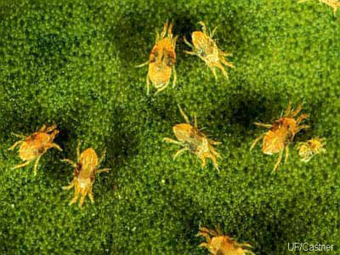Two spotted spider mites
Soybeans flower over an extended period of time. The extended period of flowering can help build yield if rains are patchy and sparse. Fields that catch rain may have areas of the plant with a lot of pods and areas on the plants where pods are sparse. Dry weather early in the season can help soybeans remain short, but still have a decent yield. It is leaves that harvest the sunshine to build yield, not stem length.
Alfalfa
Alfalfa is an amazing plant and alfalfa does a lot of good things in our systems and rotations. While alfalfa can survive a drought, alfalfa needs water to maximize yield. There are some management choices we can make to reduce the impact of drought.
Soil fertility is the backbone of alfalfa management. Follow the recommendations for phosphorus and potassium on the soil test report and correct pH prior to planting alfalfa. Potassium is important for alfalfa to withstand drought because potassium is important for proper cell hydration. Potassium is often thought of as antifreeze for alfalfa. Potassium also acts as Gatorade for plants. When we sweat, we need electrolytes to keep our bodies functioning properly. Potassium in plants functions in the same way, helping plants use water most efficiently. Phosphorus is needed in the energy transfer system of converting ATP to ADP. Phosphorus deficiency will limit yield in any environment. Under drought conditions, we want to manage the items we can manage to reduce drought's effects. Do not forget sulfur and boron. Boron is needed on sandy soils more often than on silt loam soils at rates of half pound to one pound boron per acre. Sulfur should be supplemented yearly with applications of 10 to 20 pounds of sulfate sulfur per acre. Sulfate sulfur will be found in potassium sulfate, ammonium sulfate, or gypsum.
Insects, especially potato leafhoppers, can be a problem in alfalfa and will cause severe damage in a dry year. Scout for potato leafhoppers rather than a cut and spray program. Scouting requires an insect sweep net as leafhoppers are small, mobile insects not easily detected as you walk through a field. Potato leafhoppers do not chew on the plants, but suck sap from the plant. As they are feeding, saliva is injected into the plant. The saliva plugs the vascular tissue of the plant and causes stunting and yellowing of the plant. New seedings are especially vulnerable to leafhoppers. Be sure to control leafhoppers in your alfalfa as the damage that occurs in one year can limit survival over winter and limit yields the following year. For more information and treatment thresholds, use the following link.
https://fyi.extension.wisc.edu/forage/potato-leafhopper-damage-to-alfalfa/#:~:text=The%20potato%20leafhopper%20(PLH)%20is,into%20the%20Midwest%20each%20spring.
Emergency forage
If the dry weather persists and you need feed for livestock, there are a few options to consider. Sorghums, Sudan grass, and millets are all drought tolerant, warm season grasses that can be planted up to mid-July in our area. Prussic acid poisoning can be an issue with Sudan grass and the sorghums. Grazing sorghums before they reach thirty inches in height or the regrowth from grazed or harvested sorghum will increase the chances of prussic acid poisoning. Frost damage will increase the chances of prussic acid poisoning. Delay harvesting or grazing sorghums or Sudan grass for seven to ten days after a frost so the prussic acid can dissipate from the plant. Millets do not contain prussic acid, but millets often yield less than sorghum. Soybeans or cow peas can be mixed with any of the warm season grasses to increase the forage quality of the crop.
Corn for silage can be planted up to July 4 if rain becomes reliable. Corn will yield more than sorghum or millet in our area in nine out of ten years. Sorghum will be more drought tolerant due to a more fibrous root system and a waxy cuticle.
Fall seeded oats are an interesting option. Of course, rain will need to be reliable for oats to be a viable option. Oats planted in August are a different crop than oats planted in the spring. Oats flower based on day length and lignin is accumulated in the stem (straw) to support the grain accumulation in the head. Spring planting has the plant growing in short days that increase in length and then days decrease in length after about June 22. It is the increasing, then decreasing day length that triggers heading and pollination. Oats planted in August germinate and grow in day length that is consistently getting shorter, so pollination does not occur, even though the plant often heads out. Lignin is not accumulated in the stem in late seeded oats. Sugars will accumulate in the stem and leaves in the same fashion as in barren corn. Leave fall seeded oats in the field if you can into October or November as the feed value will continue to increase as it stands. Protein will be high and energy levels will be high. Be sure to test the feed value of any fall seeded oats before feeding.
Soybeans can be used as an emergency forage. If soybeans were planted as a grain crop and treated with an herbicide, be sure to check the label to determine if the plants can be harvested for forage. Harvesting soybeans as leaves first begin to turn color will maximize dry matter yield and feed quality.
If you have crop insurance, be certain to check with your agent before harvesting any crop earlier than normal or for a purpose different from the one for which the crop was planted.
Calendar
Sundae on the Farm July 9, 10am-2pm Lincoln Rd Dairy, N6811 Lincoln Road – Taylor
Trempealeau Co. Fair July 13-16 Trempealeau Fair Grounds, Galesville
Buffalo Tremp. farmer network field day July 27, 8:30-2, Karl Geske Farm, Galesville
Jackson Co. Fair August 1-6 Jackson Co. Fair Grounds, Black River Falls

