Jackson and Trempealeau Agriculture Newsletter, Fall 2023
Storing drought stressed grain
The drought we experienced in 2023 may impact grain quality and your ability to keep grain in good condition in your bins during the storage season. If pollination was successful, but dry weather persisted through grain fill, light test weight grain may be the result. If your fields received rain during the grain fill period, yield may be down, but grain test weight and quality may be normal. Corn will abort kernels throughout the grain fill period if moisture or soil fertility is short. Depending on when the kernels are aborted, the aborted kernels may or may not impact grain quality. Kernels aborted soon after pollination will dry up and blow out the back of the combine without impacting grain quality. As dry matter begins to accumulate, kernel count will not be impacted but grain quality will be lower due to aborted kernels showing up as light weight kernels. As 2023 has gone, grain quality depends on when or if your fields received rain.
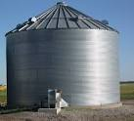 Stock Image
The concern at this time of year is how grain quality impacts storage of grain. Keeping stored grain in good condition is important to the profitability of your farm business as well as the safety of you and your family. Moldy and insect damaged grain is prone to bridging and hanging up in bins. Most grain entrapments occur in bins that have spoiled grain as people enter the bin to get the grain flowing through the unloading equipment.
Light test weight grain is subject to damage more so than heavy, dense grain. Screening grain before the grain goes into storage will eliminate most of the fine and foreign material from the grain. The fine material in grain often accumulates in the center of the grain bin under the auger where the grain enters the bin. The column of fine material is subject to spoiling as the fine material limits air flow through the grain. The limited air flow will encourage mold growth and insect damage in the bin. If you do not have a way to screen the grain, take a few truckloads of grain out of the bins soon after the bins are filled. Taking some loads out will remove the fine material from the center of the bins.
Another issue with corn this year was the difference in maturity within fields. Low areas of fields, or areas with heavier soils, mature slower than areas with lighter soils, creating varying grain moisture as you cross a field. This varying moisture will carry into the grain handling and storage structures and may create variation in the moisture and temperature of the grain entering storage. Variation in moisture and temperature can cause condensation within the grain mass. Be sure to run aeration fans longer than normal this year to equalize the grain mass.
Monitor grain quality regularly throughout the storage season. Regular monitoring will let you act to slow or stop grain quality deterioration during the storage season. Be safe when working around grain storage facilities. Never enter bins. If you must enter bins, take all safety precautions, and never work alone.

Soil pH management
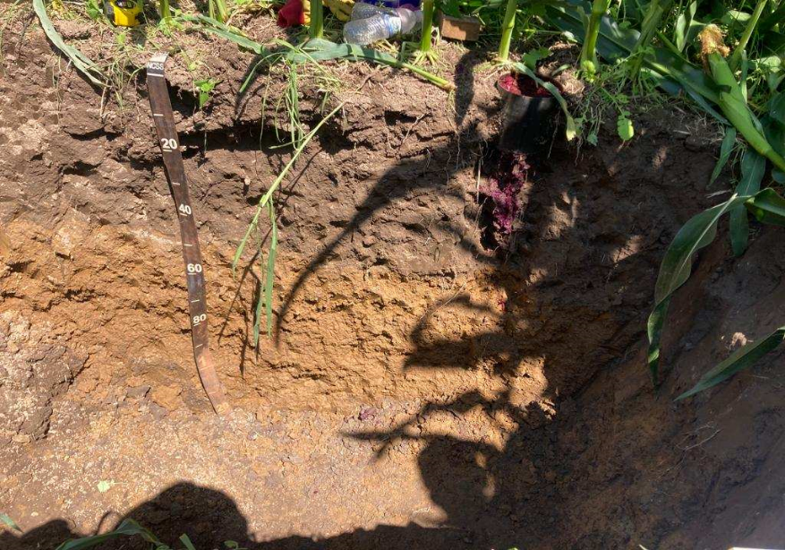 Photo courtesy Steve Okonek
Soil pH is important for soil to function properly as a nutrient storage structure for plant growth. Nutrients are stored in soil as physical adsorption or stuck to soil particles, or as a chemical structure as in nutrients contained in organic structures. Organic structures may be plant residues, animal parts, or soil organic matter itself. Nutrients are dynamic, meaning that the nutrients are continuously moving from the soil water solution to one of the physical storage structures in the soil. The soil water solution is the thin, invisible layer of water that surrounds soil particles. The movement of nutrients in and out of the soil water is a chemical process. Water content and temperature of the soil are the main drivers of soil chemistry. We have little control over the temperature and water content of our soil. Another driver of soil chemistry is soil pH. We can control soil pH through applying lime to neutralize pH or other products to lower pH or make the soil acidic.
Agricultural lime is used to neutralize pH in Wisconsin. Lime in Wisconsin is calcium hydroxide and magnesium hydroxide (CaCO3, MgCO3). Calcium or magnesium are not the elements that raise pH or reduce acidity. It is the carbonate (CO3) ion that reacts with hydrogen in the soil water to increase pH and reduce acidity. Because the carbonate ion increases pH, gypsum (CaSO4) is not a liming material for increasing pH. Gypsum is best used as a sulfur source in Wisconsin.
Increased reliance on pre-emerge herbicides requires us to pay attention to soil chemistry. Many pre-emerge herbicides rely on soil pH in the neutral to slightly acid range (6.5-7.5) for proper soil activity.
Soil testing is the only way to know how much lime your soil needs. The proper amount of lime for a crop rotation is determined by the most pH sensitive crop in the rotation. For a typical dairy farm rotation of corn and alfalfa, the most pH sensitive crop is alfalfa. Soybean would be the most pH sensitive crop in a corn and soybean rotation. Soil samples should be pulled from a field every three to five years, or more frequently in more intensive rotations and cropping systems. Using a Wisconsin certified testing lab for testing your soil samples ensures you receive results that have been calibrated to Wisconsin soils and growing conditions.
Fall is the best time to soil test and apply lime. Applying lime in the fall allows time for incorporation of the lime without delaying planting and can allow time for lime to begin to neutralize soil acidity. Soil temperature should be over 50 degrees Fahrenheit for good soil chemistry action to occur. Fields that will be planted to alfalfa in 2025 should be soil tested and limed in the fall of 2023, especially if pH is lower than 6.3.
Winter small grains as forage
Winter small grains may be a way to rebuild forage supplies after the drought of 2023. I will use all three species of winter small grains interchangeably in this article since most differences are minor between the species. The three species being rye (Secale cereale), triticale (Triticosecale), winter wheat (Triticum aestivum).
Before October is the optimum time to plant winter small grains to maximize forage yield, with yield dropping significantly if rye is planted after October 12. Use a seeding rate of 90-112 pounds per acre for forage. Optimum grain yield is achieved with 60-90 pound per acre seeding rate.
The optimum nitrogen (N) rate if you are using commercial N is 40-60 pounds per acre of N. If you are using manure, the optimum nitrogen rate per acre is 80 pounds per acre. The higher N rate with manure accounts for variability in the mineralization of N from manure and variability in application rates. Consider taking fall soil nitrate tests after corn silage harvest to determine if additional N will provide an economical return. Soil nitrate levels are often high after a drought like we are experiencing now.
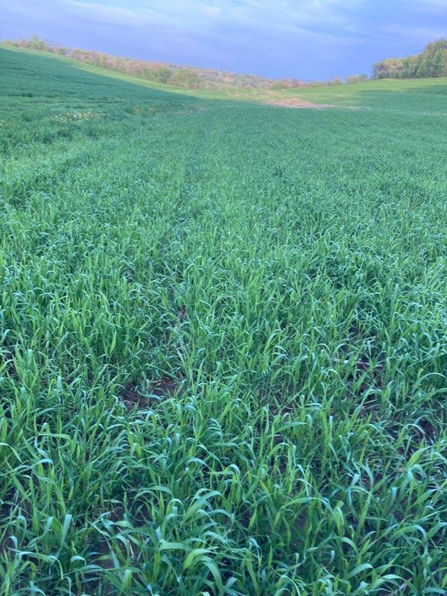 Photo courtesy Steve Okonek
Most farms have sufficient phosphorus and potassium to produce winter cereal forage without adding additional fertilizer for these nutrients. Rye can be a luxury consumer of potassium. Testing rye forage before feeding is essential, especially for dry dairy cows as high potassium levels in the forage may increase the chances of milk fever in fresh cows.
Cereal grains should be harvested for forage while in the boot stage. The boot stage is the best compromise between tonnage and quality. Harvesting earlier will produce higher quality forage with a lower tonnage and harvesting later will produce more yield with less quality. Yields of 2-4 dry tons per acre are possible with Rye. Triticale and winter wheat will be slightly lower in tonnage than rye. While there are slight quality differences in the cereals with rye being slightly lower in quality than wheat and triticale, the largest gain in quality can be made with harvest timing.
Keep in mind that winter cereals are ready for harvest in mid to late May. Wet weather may delay harvesting the crop, reducing quality of feed, and causing soil compaction and rutting of fields.
For more information on harvesting cereal rye for forage, use this link: https://tinyurl.com/46hy3dr2
Calendar
The Small Ruminant Workgroup is hosting a beginning shepherd and goat producer workshop, Flocking Together, on October 19-21. Please help us promote by sharing the "Save the Date" from the Extension Crawford County Wisconsin | Prairie du Chien WI | Facebook.
We will share additional information and registration information soon.
Thank you! If you have any questions, please do not hesitate to contact Carolyn Ihde at cihde@wisc.edu.

Grain marketing, introduction to grain marketing for transitioning dairy farmers and beginning farmers, December 7, location, and time to be determined. Stay tuned for more information.

