Spring newsletter
Cover crop considerations
Cover crops can do many beneficial things for us. Cover crops can help improve soil health by reducing erosion. If you want to increase soil health, first you need to reduce or stop soil erosion. When soil erodes, not only does the A horizon (the good, black topsoil) become thinner, but clay and organic matter are reduced as water sorts out those particles and moves them off-site, leaving coarse materials such as sand and gravel. Clay and organic matter are the lightest of the soil constituents while sand is the heaviest. Sand stays behind and clay and organic matter move off-site to surface waters and road ditches. Increasing residue cover and increasing the length of time that living roots are in the soil to bind the soil together lessen the amount of soil that can be eroded.
Cover crops add another layer of management to our cropping systems. One consideration is when to terminate the cover crop. Allowing the cover crop to grow to 30 inches in height, or 4500 pounds dry matter per acre, will assist in suppressing water hemp. The rye should be seeded at 60 pounds per acre or a little heavier. Use a higher rate if broadcasting the rye and a lower rate (60 lbs. if drilling). The rye does not have to be roller crimped to suppress water hemp and other weeds. Below are two graphs that show the level of suppression of water hemp with and without a pre-emerge herbicide. Using a pre-emerge herbicide with a rye cover crop will help control water hemp and other weeds. Use cover crops and herbicides together for best results.
If the weather is dry, as it was in 2023, allowing the rye cover crop to grow to that height may deplete soil moisture to the point it will hurt the cash crop. Each year will require flexibility as to termination date and the growth stage of the cover crop. In a wet season, leaving the cover crop to grow longer will improve soil moisture and allow you to plant earlier than you would be able to plant into a bare field.
Planting green is a technique that allows the cash crop to be planted earlier while the cover crop continues to grow to help suppress water hemp and provide more residue for ground cover. The cover crop is terminated later, often after the cash crop has emerged. There are a few issues that can occur with planting green. One issue can be getting seed in the ground so a uniform stand can be established. If there is a heavy cover crop stand, be certain that seed is in moist soil, the seed furrow is closed and seed is covered. Residue managers may need to be adjusted and watched that the cover crop is not wrapping around the residue managers. Soybeans are less likely to suffer a yield drag from having the cover crop growing alongside the cash crop. Corn is more susceptible to yield drag and the cover crop needs to be terminated shortly after planting corn.
Use cover crops as a tool to control problem weeds. Cover crops are not a stand-alone weed control method. Cover crops will require a new level of management, but with attention to detail, a lot can be accomplished with cover crops.
Summer forage options
As I am writing this article, I don’t know if the alfalfa will survive the crazy winter we had or not. I also don’t know if the growing season will be dry or wet. I will assume we will be short on forage and I will lay out some options.
If alfalfa winter kills, stands can be thickened with annual ryegrass. This will not come close to replacing the tonnage that alfalfa will normally provide and should only be done on a few fields. The best option is to finish killing the alfalfa field with glyphosate and 2,4-D or complete tillage like moldboard plow and plant corn. Corn silage can be used to replace the yield difference between new seeded alfalfa and established alfalfa. Seed other fields to alfalfa to replace the acreage and get your crop rotation back on track as fast as possible. If the field was a good to excellent alfalfa stand in the fall, you will not need to add nitrogen to grow a corn crop. Following is a table illustrating the nitrogen credit from alfalfa.
Nitrogen credits from alfalfa
First year lbs. N per acre to credit
Medium/fine texture sandy loam/sands
Crop stand density >8” grwth <8” grwth >8” grwth <8” grwth Red Clover
Good (70-100%) > 4 plants/sqr. ft. | 190 | 150 | 140 | 100 | 80%
Fair (30-70%) 1.5-3 plants/sqr. ft. | 160 | 120 | 110 | 70 | 80%
Poor (0-30%) < 1.5 plants/sqr. Ft. | 130 | 90 | 110 | 40 | 80%

The red clover credit is 80% of the corresponding alfalfa credit. Vetch has a similar nitrogen credit to red clover.
Sorghums and Sudan grass
Sorghums, both grain sorghum and forage sorghums, can be grown in Wisconsin. Keep in mind that most years, corn will yield more tonnage per acre than the sorghums will in Jackson, Trempealeau, and Buffalo Counties. The climate is more conducive to corn in our area because we tend to be cooler than the ideal temperatures for the sorghums to thrive. The exception would be a hot, dry summer or sandy soils that tend to be too dry to grow a good corn crop. Of course, a few acres each year can be planted to sorghums as a hedge against drought. Do not plant sorghums until the soil has warmed to 70 degrees Fahrenheit.
Prussic acid can be an issue with the sorghums and Sudan grass. Do not harvest or graze sorghums under 24 inches of height or sorghums within 10 days of a frost. Fermentation and drying can reduce the amount of prussic acid in forage, however, the best way to avoid prussic acid poisoning is to harvest sorghums at the proper height or time interval after a frost.
Nitrate poisoning can be an issue with corn, sorghums, and other forage grasses, particularly in dry weather. Do not harvest or graze the bottom 8-12 inches of the stalk of corn or sorghums. If you are grazing or harvesting sorghums for more than one harvest per season, you need to leave the bottom 8 inches as sorghums regrow from buds at the bottom of plant. Cutting or grazing lower than this can reduce the yield of subsequent harvests while increasing the chances of nitrate poisoning. High nitrate feedstuffs will increase the amount of silo gas produced in fermentation.
Millets
Millets are a warm season forage and grain crop with similar growth to the sorghums without any risk of prussic acid poisoning. The yield of millets will generally be lower than the sorghums. Millet requires warm soil temperature to germinate and grow. Protein content of sorghums and millets will be around 14-16%. Target these forages to dairy heifers and other animals that do not require high protein levels.
Soybean and cowpea
Soybean and cowpea can be mixed with sorghum or millet for a warm season legume grass mix or grown by themselves for a legume hay type forage. If you are using pure stands of soybean as a forage, be sure to read the label of any herbicide you are using or planning to use. Most soybean herbicides are not labeled for soybean used as forage! If soybean or cowpea is mixed with a warm season grass, key in on the grass to time harvest. Soybean and cowpeas tend not to regrow after they are cut or grazed and should be counted on for one cutting or grazing. Some will regrow, but most will not or the regrowth will be weak. Protein content of millet or sorghum mixed with soybean or cowpea will be higher than sorghum or millet alone, up to 18% protein. Soybean or cowpea can be up to 20% protein. Fat content can be high if the pods are filling when you harvest the forage. Be sure to test the forage before you feed it.
Cocktail mixes
There are many mixes of forage seed available from companies. Most mixes are thought out and assembled with some thought and logic to meet a need on a farm. Some mixes appear to be floor sweepings and the shotgun approach is taken to put some of these blends together. Plant blends or varieties that are adapted to your area and meet your goals. Generally, the fewer the species in a blend, the better as some of the species may be diluted down to the point that it becomes questionable if the species will show up in the stand. Some blends have cool season species such as annual ryegrass mixed with sorghums. The logic is this blend will produce something whether it is a cool summer or hot summer. This may or may not work. Be cautious. With any purchase for your farm, buy from a reputable dealer and follow their recommendations when using cocktail mixes.
Nitrogen Optimization Pilot Program (NOPP)
NOPP is a grant program from Wisconsin Department of Agriculture (DATCP) to help farmers conduct on-farm research to determine the optimum nitrogen rate for their farm. The test plot may or may not include manure, cover crops, biological products, and various rates of nitrogen. The deadline for application to the NOPP grant is passed for 2024. NOPP is set up with a stipend for farmers and their consultant to cover some of their time. There is also a stipend to cover yield loss associated with a zero N plot. A zero N plot is required to determine the optimum rate of N for a field. Some fields in some environments may not respond to added N. If there was not a zero N plot, the optimum N rate would show up as the lowest applied N rate in the study.
The following graphs are from a NOPP test plot that was completed in 2023 on Joe Bragger’s farm in Buffalo County. This study was set up to determine the optimum nitrogen rate following poultry litter on corn following corn fields. The way in which the manure in the barns are managed has changed and farmers were observing a difference in corn response to poultry litter as the management changes were made in the barns.
As you know, the summer of 2023 was dryer than normal. The dry weather may have affected the corn crop response to manure and nitrogen. This test will be conducted again in 2024 using the same methods and rates of manure and nitrogen.
Corn that received poultry litter yielded better than corn without litter. No sulfur was applied to the corn. As we know, manure is a good source of sulfur. The yield response may have been to sulfur in the manure. In either treatment, with or without manure, there was no statistical difference in yield with N applications over 60 pounds per acre.
Table of yield results
 | Control |  |  | Poultry Litter
60 N rate (lb-N/ac) | Yield (bu/ac)
0 | 116 |  |  | 186
60 | 185 |  |  | 208
120 | 180 |  |  | 212
180 | 173 |  |  | 218

Yield comparison bar graph
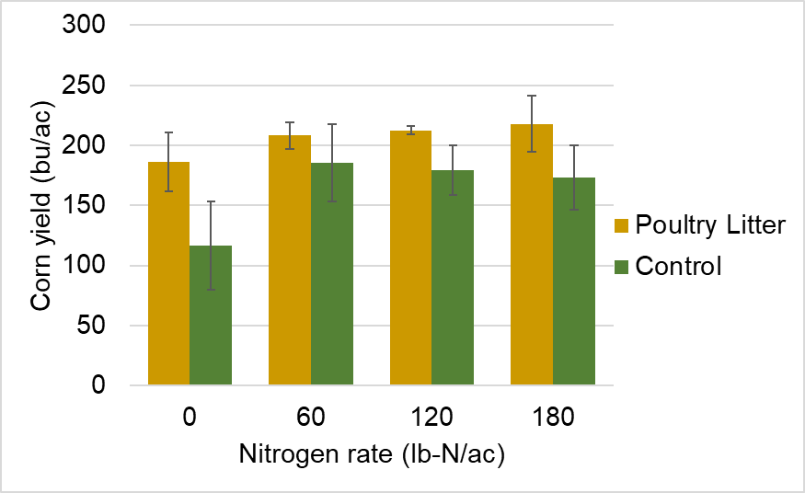
If you are interested in a NOPP plot, watch for information from DATCP in the fall of 2024, or contact me at 715-538-5097.
There will be some summer field days around Jackson, Trempealeau, and Buffalo Counties regarding NOPP and other crop management practices.
Catastrophic Animal Mortality Planning
The Division of Animal Health at DATCP is conducting four regional workshops on Catastrophic Animal Mortality Planning. The purpose of these workshops is to provide producers practical tips and information on planning for unexpected mass mortalities of their livestock or poultry whether by foreign animal disease, tornado, building collapse, etc. While the focus of the classes is on larger producers, particularly those classified as CAFOs, smaller and medium sized producers are also welcome. Dairy, beef, swine, poultry – all are welcome. These workshops would not benefit small backyard herd or flock owners. We are looking at approximately 40 people per session maximum.

Each session will be approximately four hours in length and will be held from 10 am to 2 pm each day. Below are the tentative dates and locations:

June 20, 2024 – Dodgeville (Law Enforcement Center)
June 21, 2024 – Elkhorn (Walworth County HHS Building)
August 13, 2024 – Green Bay (STEM Building at UW GB)
August 14, 2024 – Eau Claire (Extension Building)

Registration details and further information will be available in the coming weeks. Please let the producers you work with know of this training opportunity, and feel free to forward to any colleagues I may have missed. Questions can be directed to me. Thank you.

Kurt E. Grajkowski
Emergency Services Coordinator
Division of Animal Health
Wisconsin Department of Agriculture, Trade and Consumer Protection

 608-640-7556
 kurte.grajkowski@wisconsin.gov

